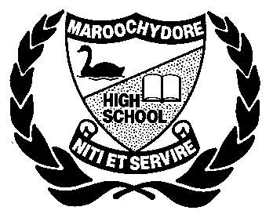
MAROOCHYDORE STATE HIGH SCHOOL

YEAR 11 – CHEMISTRY SEMESTER ONE

LIMITING REAGENT
- Consider the reaction:
2 H_{2(g)} + O_{2(g)} → 2 H₂O_{(g)}
Identify the limiting reagent in each of the reaction mixtures given below;
a) 50 molecules of H₂ and 50 molecules of O₂.
b) 100 molecules of H₂ and 40 molecules of O₂.
c) 100 molecules of H₂ and 60 molecules of O₂.
d) 0.50 moles of H₂ and 0.75 moles of O₂.
e) 0.80 moles of H₂ and 0.75 moles of O₂.
f) 1.0 g of H₂ and 0.25 g of O₂.
g) 5.0 g of H₂ and 56 g of O₂.

- Magnesium and Chlorine react together according to the following equation;
Mg_{(s)} + Cl_{2(g)} → MgCl_{2(s)}
If 20.0 g of Magnesium and 20.0 g of Chlorine are available for a reaction, determine:
a) The limiting reagent.
b) the mass of MgCl₂ formed

- Hydrazine is used in rocket fuel. It reacts with Oxygen according to the equation below
N₂H_{4(l)} + O_{2(g)} → N_{2(g)} + 2 H₂O_{(g)}
In a particular rocket engine, 2.29 g of hydrazine and 3.14 g of Oxygen are available to react.
a) Find the limiting reagent
b) Determine the mass of unreacted reagent that will be left after the reaction
c) Calculate the mass of water produced.

- When a mixture of Silver metal and Sulphur is heated, Silver Sulphide is formed:
16 Ag_{(s)} + S_{8(s)} → 8 Ag₂S_{(s)}
a) What mass of Silver Sulphide is produced from a mixture of 2.0 g of Silver and 2.0 g of Sulphur?
b) What mass of reactant is left unreacted?

- Ammonia (NH₃) is produced from the reaction between Nitrogen (N₂) and Hydrogen (H₂).
a) What is the maximum mass of ammonia that can be produced from a mixture of 1 X10³ g N₂ and 5 x 10² g H₂?
b) what mass, of which starting material, will be left over?

